**APEX COLLEGE**

**POKHARA UNIVERSITY**

**LAB REPORT OF**

**DOT NEW TECHNOLOGY**

**LAB-7**

**Submitted By:                                               Submitted To:**

**Ruchi Agrawal                                               Bishwomitra Adhikari**

**BCIS ‘Adware’** **Ananta Pant**

**Roll no: 18**

**Objectibe: To ApexRestaurant.Api Setup for Web Services/Web API & Testing via Postman**

**Theory**:

The Postman is the most popular and the most powerful HTTP client for testing the restful web services. Postman makes it easy to test the Restful Web APIs, as well as it develops and documents Restful APIs by allowing the users to quickly put together both simple and complex HTTP requests. The Postman is available as both a Google Chrome in-browser app and Google Chrome Packaged App.

The packaged app version of Postman provides many advanced features that include**OAuth 2.0** support and **bulk uploading/importing** that are not available with the Google Chrome in-browser app version. The in-browser version includes a few features, such as session cookies support, that are not yet available in the packaged app version.

**GET Request using Postman:**

Select the HTTP Method as “GET” and enter the URL of your Web API as shown in the below image.



Once we click on the Send button, an HTTP request is sent to the provided URL. The response coming from the Web API Server is displayed in the below image.

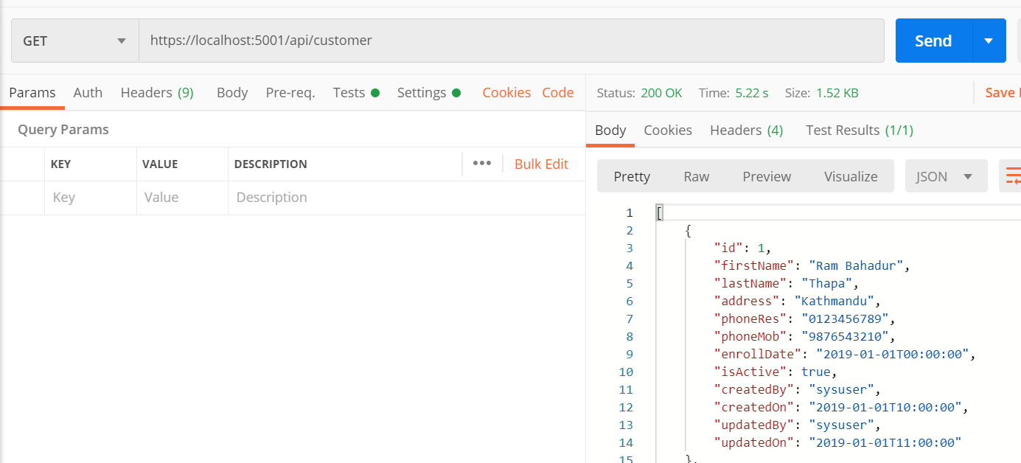

**POST Request using Postman:**

1. Choose the HTTP verb as **POST**
2. Set the URL
3. Set the Content-Type as **application/json**. To do this click on the Header tab and provide the key value as shown in the ‘”””below image

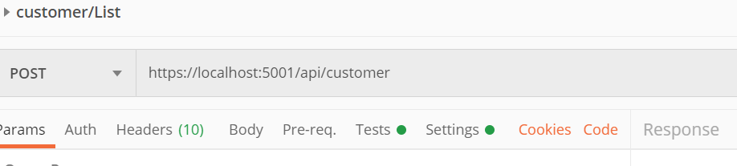

Code:

**Navigate to “appsettings.json” file and add “ConnectionStrings” section:**

{

  "ConnectionStrings": {

    "DefaultConnection": "Server=.;Database=ApexRestaurantDB;Trusted_Connection=True;"

  },

  "Logging": {

    "LogLevel": {

      "Default": "Information",

      "Microsoft": "Warning",

      "Microsoft.Hosting.Lifetime": "Information"

    }

  },

  "AllowedHosts": "*"

}

**Conclusion**

In this lab, we learned about postman. The Postman is the most popular and the most powerful HTTP client for testing the restful web services. We learned about how Postman makes it easy to test the Restful Web APIs,